Supplementary Material
STR result of Siha cell
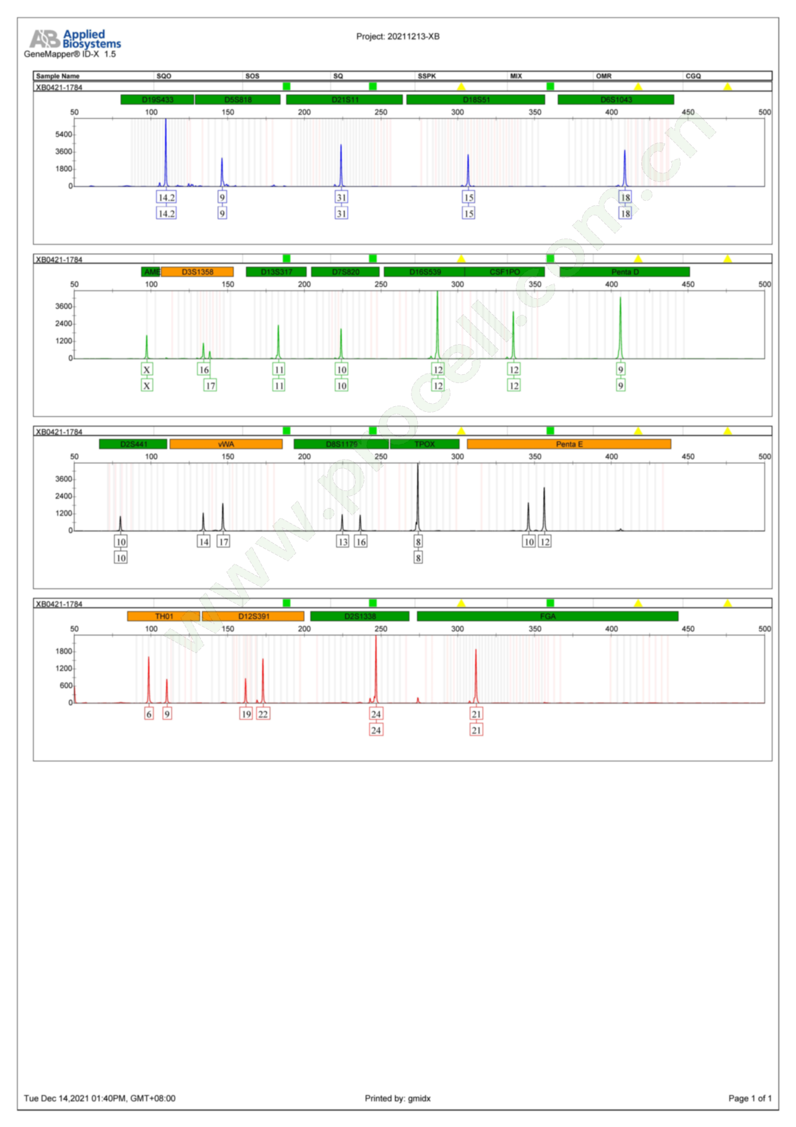

STR result of Hela cell
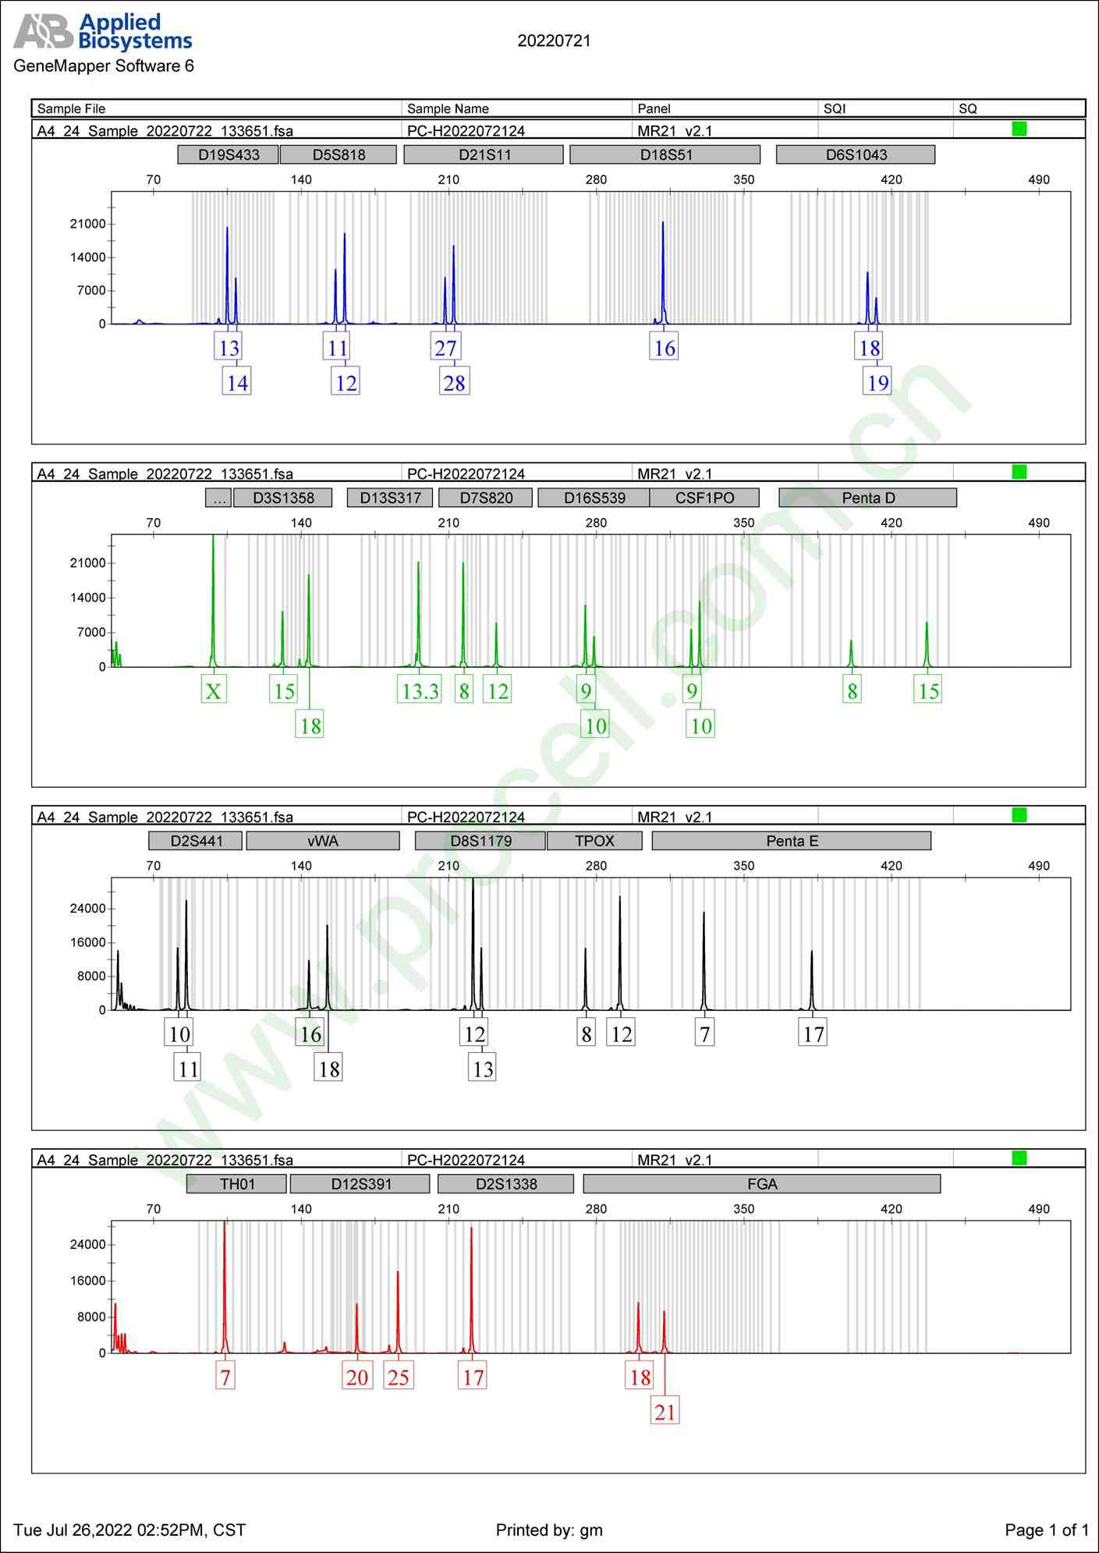

Cells Culture and Preservation
Culture conditions
DMEM+10%FBS+1% streptomycin, 37℃, 5% CO₂
Growth properties
Adherent growth, epithelioid
Cell recovery
- Cells cryopreservation tube from liquid nitrogen quickly thaw it at a water bath (37°C), and then wipe the outer wall of the cryopreservation tube with 75% alcohol;
- Transfer the cells to a 15 mL centrifuge tube containing 5 mL of complete culture medium, and centrifuge at 1000 rpm for 5min;
- Discard the supernatant, precipitate and resuspend with 5 mL of complete culture medium, inoculate with T25 culture flask, and culture in a cell incubator at 37°C, 5% CO₂.
- The next day, continue the culture with fresh and complete medium.
Cell passage
- When the cells grow to 80% of the area covered by the culture bottle, discard the culture liquid in the T25 culture bottle and wash the cells with PBS once;
- Add about 1mL of 0.25% trypsin digestion solution to a culture bottle, observe it under an inverted microscope, add 5 mL of complete culture solution to terminate digestion after the cells shrink and become round, gently blow the cells to shed, and then transfer the suspension to a 15 mL centrifuge tube, centrifuge at 1000 rpm for 5min;
- Discard the supernatant, precipitate and resuspend with 1-2 mL of complete culture medium, and then subculture them in a 1:2 ratio. Add a new complete culture medium to 5-8 mL/bottle, and finally culture them in a cell incubator at 37°C, 5% CO₂.
Cell cryopreservation
- When the cells grow to 80% of the area covered by the culture bottle, discard the culture liquid in the T25 culture bottle and wash the cells with PBS once;
- Add about 1ml of 0.25% trypsin digestion solution to a culture bottle, observe it under an inverted microscope, add 5 mL of complete culture solution to terminate digestion after the cells shrink and become round, gently blow the cells to shed, and then transfer the suspension to a 15 mL centrifuge tube, centrifuge at 1000 rpm for 5 min;
- Discard the supernatant, precipitate the cells, and add 1 mL/tube of serum-free cryopreservation solution. Mix well and add to the cryopreservation tube;
- Put the frozen cells directly into a refrigerator at - 80°C; If cells are to be transferred into a liquid nitrogen tank at a later stage, they need to be stored in a refrigerator at - 80°C for more than 24 hours.

Supplementary Figures
Supplementary Fig. 1. The images of cell cycle in Hela and SiHa cells.

Supplementary Fig. 2. The images of cell DNA damage in HeLa cells. (A) The cell DNA damage induced by cisplatin. (B) The cell DNA damage induced by paclitaxel.

Supplementary Fig. 3. The images of cell DNA damage in SiHa cells. (A) The cell DNA damage induced by cisplatin. (B) The cell DNA damage induced by paclitaxel.

